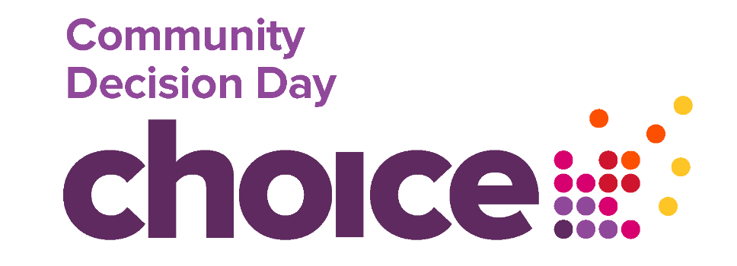
Saturday 16th November 2024

Do you live in the Ballymena area?
Have you got an idea for a community project?
Need up to £1000 to put it into action?

We are running a CHOICE Community Decision Day event in your area. This means groups/sponsored individuals can apply for up to £1,000 and it is the local community who decides what projects are selected. Eight awards of up to £1000 each are available.

Criteria for Applications

Who can apply?
You don't have to be an existing group with your own constitution to apply. You just need a minimum of three people who have an idea for a project and a constituted group to sponsor your entry.
Groups with a constitution are also welcome to apply.

When and where should projects take place?
Your project should take place between late November 2024 and 14th February 2025 and must take place in Ballymena town or within 5 miles of the town or, be for residents who live within 5 miles of Ballymena town.

What can we apply for?
You can apply for up to £1,000 to pay for things such as equipment, events, tutors, venue hire, transport for trips and other innovative ideas.
There will be £1000 awarded to each of the four top scoring projects.
Your project must demonstrate how it relates to one or more of our FIVE THEMATIC PRINCIPLES:
- Health and wellbeing
- Education, Training and Employment
- Community Development
- Arts and Culture
- Advice and Advocacy
We will assess your project to ensure it is legal, safe, achievable within budget, and achievable within timescale.
There are a few things that we can't pay for such as salary costs, gift cards or gift vouchers, alcohol or political activities. Please contact us if you are not sure.

How do I apply?
Submit completed application form by email before Monday 11th November at 8pm to: info@ffksolutions.com
The application form can be found on pages 4 – 6 You can submit the whole document no need to separate.

What happens next?
- When you submit your entry, we will check that it meets our themes - we might give you a call for some further information.
- We aim to let groups know if they've been shortlisted by Tuesday 12th November 2024
- The shortlisted projects will be required to exhibit their proposal at the CHOICE Community Decision Day event on Saturday 16th November 2024 from 11am to 3.00pm at Fairhill Shopping Centre, Ballymena (Unit opposite Town Town, Academy Mall)
- At the CHOICE Community Decision Day you will inform the voters what you plan to do and what you hope to achieve as they visit your stand. All you need to do is tell them some information about what you do. what the project is about and how this will be good for the Ballymena area. You can do this by using pictures, posters and/or display boards etc.
- The people attending the CHOICE Community Decision Day will vote on which projects should be funded. They will be required to vote for at least eight projects.
How does the voting work?
- After all the projects have been visited by everyone who attends the CHOICE Community Decision Day they will have the opportunity to vote.
- Each person will have the opportunity to vote for Eight projects.
- The 8 groups that receive the highest number of votes will receive an award.
- The successful projects will be announced as soon as possible after the event.
- Any unsuccessful groups will get advice and support.

What happens after the voting?
Successful projects will have until 14 February 2025 to deliver their project activity and will be required to submit evaluation and finance reports by 28th February 2025.

What support is available
Please get in touch with any questions to:
Andrew Kernaghan email - info@ffksolutions.com
Marian Fitzpatrick Tel: 07753937543 if you have any difficulties with application form.

APPLICATION FORM
GROUP INFORMATION
Group name
Contact person
Correspondence address

Telephone
Email
Do you have a written governing document e.g. constitution? | Yes | No
If you tick Yes, please include a copy when submitting your application.
If you tick No, you need to provide the details of a sponsor below.

SPONSOR INFORMATION
For individual/ non -constituted applicants
Name of constituted group/organisation that agrees to sponsor your entry
Sponsor contact name | PRINT NAME
Sponsor Signature | SIGNATURE
Sponsor Telephone

Sponsor Email

PROJECT DETAILS
What Is the name of your project, where and when will it take place?
(Max 100 words)

Please tick the relevant theme/s that your project relates to:
1. | Health and wellbeing
2. | Education, Training and Employment
3. | Community Development
4. | Arts and Culture
5. | Advice and Advocacy

Please describe your project and why it would be good for the Ballymena area and/or 5 mile radius area:
(Max 600 words)

How much money do you need and how do you plan to spend it?
Remember you can bid for a maximum of £1,000. Give us a breakdown of your costs.
(Max 500 words)

DECLARATION
By submitting your entry you are agreeing to the following statements:
- You have been authorised by your organisation/ group to submit this entry.  - All the information you have provided in the application is accurate and complete and you will notify us of any changes.  - You understand that we will use any personal information you have provided for the purpose described under our Data Protection Statement and in line with our Privacy Policy.  - If information about this application is requested under the Freedom of Information Act. We will release it in line with our Freedom of Information Policy.  - You or your sponsor organisation will provide a copy of your (their) signed constitution or set of rules, public liability insurance and child protection/ vulnerable adults policy (If applicable) upon request. | - Any information you give us will be used during the assessment and life of your project (if successful) to administrate, evaluate and for our own research purposes. We may give copies of all or some of this information to individuals and organisations we consult with when assessing the bids, administering the programme and monitoring and evaluation.  - A description of your project may be published by Choice Housing on our media platforms.  - The project will take place within the Ballymena area/ within 5-mile radius of Ballymena.

I confirm my group will attend the CHOICE Community Decision Day event on Saturday 16th November 2024 Yes/No

ATTENDANCE AT THE EVENT IS A CONDITION OF AWARD

PRINT NAME

SIGNATURE
Can be electronic
DATE

